Suzhou
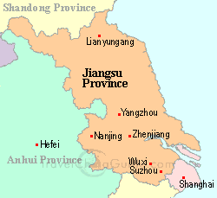Location: situated in the south of Jiangsu Province, in the middle of the Yangtze Delta; in the lower reaches of the Yangtze River and on the shores of Taihu Lake, bordering on Shanghai in the east, Zhejiang Province in the south , Taihu Lake in the west and the Yangtze River in the north; between north latitude 3047' - 3202', east longitude 11955' - 12120'.
Neighboring Areas: Zhejiang, Anhui, Shandong Provinces and Shanghai Municipality
Physical Features: 10 percent is cultivated fields, 30 percent hills, and the rest covered with water, low and smooth terrain with altitude of 4 meters above sea level
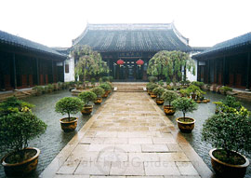
Population: 5.71 million
Urban Population: 1.05 million
Area: 8,488 sq km
Nationalities: Han, Hui, and Manchu
History: also known as "Gusu city", having the fame of "Oriental Venice", Suzhou was set up in BC 514; being a city with history of more than 2500 years, it was named Suzhou in A.D.581, Sui dynasty.
Climatic Features: in the north edge of subtropical zone, monsoon maritime climate; mild and humid; with enough sunshine
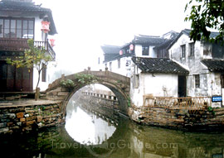
Average Temperature: annual average temperature 15.7C
Mountains: Mt. Lingyan, Mt. Tianping; Tiger Hill; Mt.Yushan
Rivers: the Yangtze River, Yangcheng Lake, Chenghu Lake; Jinghang canal
Local Highlights: Kunqu Opera, Suzhou Opera and Ballad-sing; silk; handicrafts such as: Suzhou Embroidery, Fans, national musical instruments, scroll mounting, lanterns, mahogany furniture, jade carving, silk tapestry, traditional painting pigments of Jiangenxutang Studio, the New Year's wood-block prints of Taohuamu Studio, etc; Yangcheng Lake huge crab

